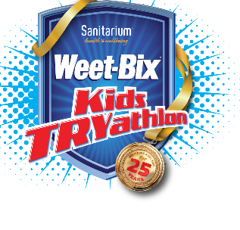
Weet-Bix TRYathlon 2020

Friday 8th November 2019

Dear Parents

Our school has registered as a school group for the Christchurch Weet-Bix Kids TRYathlon to be held on Sunday 23rd February 2020 at Jellie Park, Burnside, Christchurch. The Weet-Bix Kids TRYathlon is for Kiwi kids of all sporting abilities who are aged between 6 and
15. Children can enter as individuals and do all three legs of the TRYathlon by themselves or in a team of two and do either the swim/run or bike/run with a friend.

Event Info https://tryathlon.co.nz/locations/christchurch/

The fee to participate in the Weet-Bix Kids TRYathlon is $50 online, however, all students who enter by linking to our school group when registering at home will receive the special 'School Group Entry Price' of $45 if you register before the EARLYBIRD cut-off date of Sunday 2nd February 2020.

You can register at home using this URL link which links to our school group – West Melton School.

Morning Session:
https://www.registernow.com.au/secure/Register.aspx?E=35577&G=98535

Afternoon Session:
https://www.registernow.com.au/secure/Register.aspx?E=35578&G=98551

WHEN: Sunday 23rd February 2020 - Morning and Afternoon Sessions

WHERE: Jellie Park, Burnside, Christchurch

The Weet-Bix Kids TRYathlon in Christchurch will return to Jellie Park this year. The swim is located in the Jellie Park Recreation & Sport Centre in a 50m heated outdoor pool. The Transition Area is located outside of the pool complex, on the nearby fields, and the bike and run legs of the Weet-Bix Kids TRYathlon around the field and surrounding streets.

Kind regards,

Nicole Dunlop
sport@westmelton.school.nz

